**::CIS 25 Fall 2016:: Assignment 8 Modulus Escape Characters**

**Student ID:** 10831438

Symbol ( % ) in c++ programming basic arithmetic- Modulo. Gives you the remainder

20 % 3 = 2

**Character Escape Sequences-**

|  |  |
| --- | --- |
| **Escape code** | **Description** |
| \n | New line |
| \r | Carriage Return |
| \t | Horizontal Tab |
| \v | Vertical Tab |
| \b | Backspace |
| \f | Form Feed |
| \a | Alert |
| \' | Single Quote |
| \" | Double Quote |
| \? | Question Mark |
| \\ | Backslash |

Print the sentence… Using a single output stream and escape sequences. Include your name in “” quotes. Do not use + or multiple lines Attach a small snipping photo below.

**C++ is Great “YourName” I am really learning a lot!**

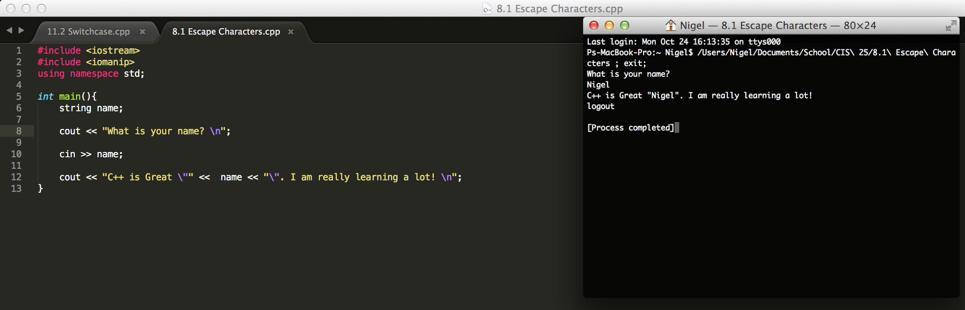

**LAB ASSIGNMENT**

**1st Task:**

Write a computer program that will receive user input as an integer. Prompt the user to input year. Your program will output if the number entered is a leap year.

Create a whiteboard/pseudocode example. Of who you will solve the problem.

You will need to use the % and logical operators.

Research the way a leap year is calculated.

Make sure to prompt and format output correctly.

**Sample Outputs**

**“Enter Year”** // User prompt

**2000**

**2000 is a leap year** // Output

**“Enter Year”** // User prompt

**190**

**190 is not a leap year false** // Output

